ICMC2026 Hamburg

Augmented Improvisation: Machine Learning as a Live Performance Partner
Real-Time Audio–MIDI Interaction and Predictive Feedback for Dynamic Musical Dialogue

Abstract
This music presentation explores live improvisation through a prototype system that provides real-time predictive MIDI feedback derived from combined audio and performer control data. The performance integrates guitar and voice processed through MIDI-controllable effects, where audio features and high-resolution MIDI streams are analysed continuously to anticipate likely parameter changes during improvisation. Rather than generating musical material autonomously, the system offers predictive suggestions that influence sound transformation, supporting an interactive, human-in-the-loop approach. The work foregrounds performer agency, responsiveness, and emergent musical structure, treating prediction as a catalyst for exploration rather than a prescriptive mechanism. The presentation demonstrates how machine learning can function as an improvisational partner, shaping evolving textures, gestures, and formal trajectories in real time.

Introduction
Improvised performance inherently relies on responsive, context-sensitive decision-making. Traditional interactive systems often generate material autonomously or operate on symbolic representations, limiting their responsiveness to live performance nuances. This presentation investigates a human-in-the-loop approach in which predictive models analyse high-resolution audio and MIDI data in real time, offering suggestions rather than enforcing outcomes.

The system supports guitar and voice performance routed through MIDI-controllable effects, allowing each performer to explore new timbres, gestures, and textures. By anticipating likely parameter changes, the predictive feedback enhances improvisational possibilities while preserving artistic agency. The performance demonstrates a prototype framework for machine-learning-informed interaction, highlighting how predictive models can act as creative collaborators, fostering emergent musical structures and real-time experimentation.

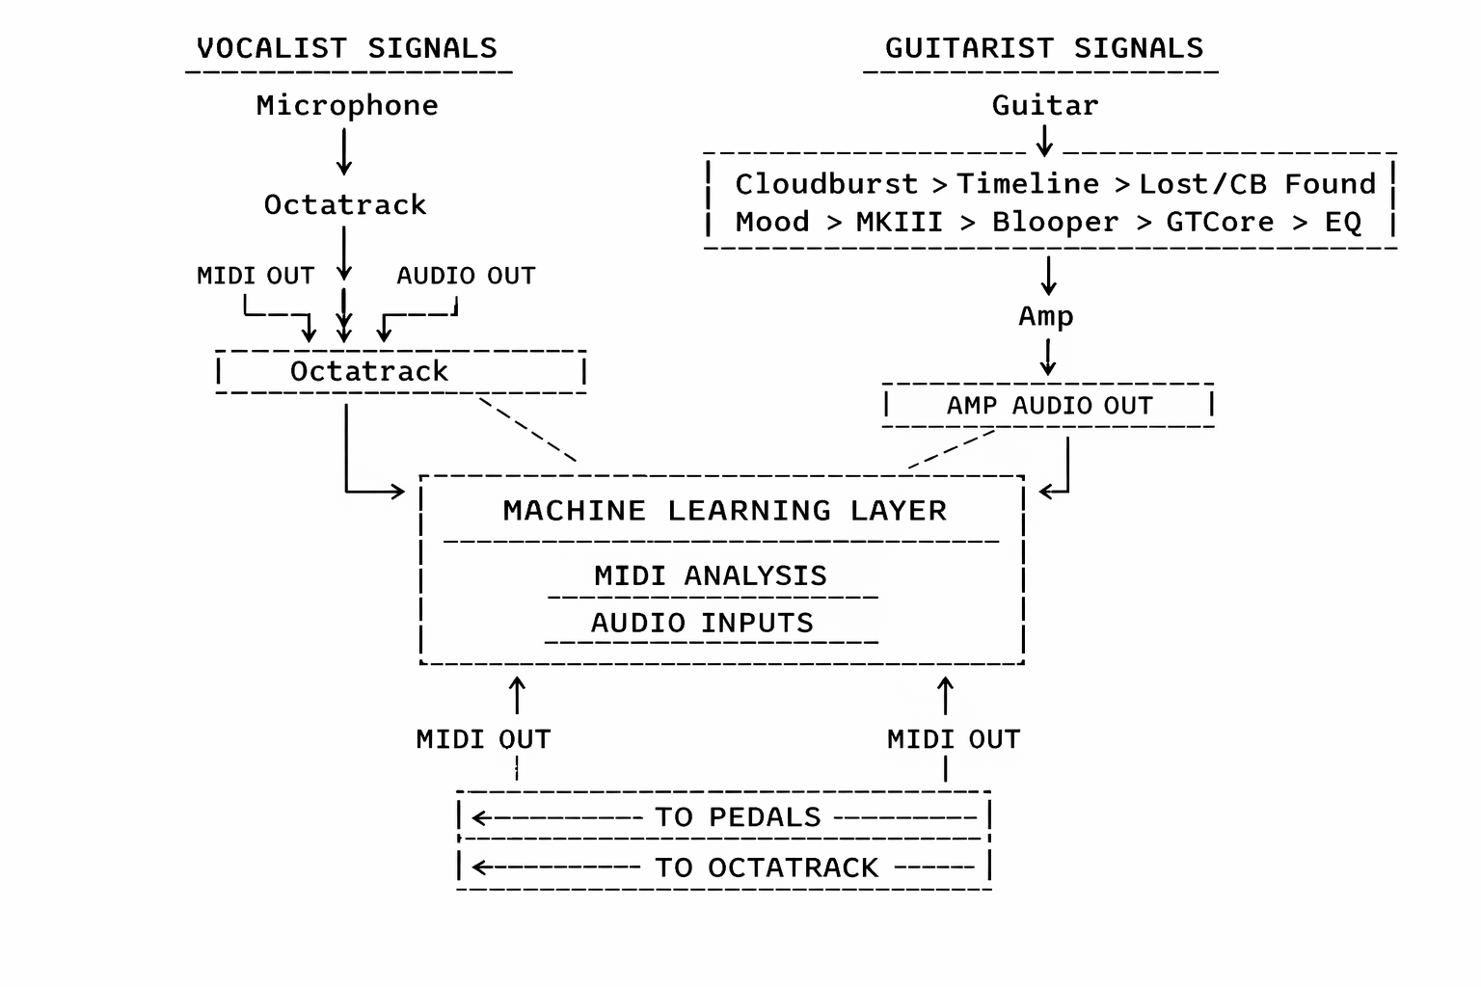
Figure 1. Signal flow diagram of a live vocalist and guitarist setup integrating audio and MIDI streams through a central Machine Learning Layer. The vocalist’s microphone and Octatrack, and the guitarist’s multi-effect pedal chain and amplifier, feed both audio and MIDI data into the Machine Learning Layer, which processes inputs and returns MIDI control signals to pedals and Octatrack, enabling interactive real-time performance and generative control.
Note that separate paper has also been submitted detailing methodology and related code.

